**A Framework for Designing**

**a Healthcare Outcome through Data Mart**

Vishnhav Ashok A20376563

Phanindra Chandraprakash A20376416

Meenupriya Mahendran A20374392

Vijay Raghavendar Harimadhavan A20387806

Illinois Institute of Technology, Chicago, Illinois

Department of Information Technology and Management

**Topic:**

Data Mart for a Health Care System

**Details:**

There are always numerous patients visiting the healthcare system with different outcomes. When these outcomes are modelled they are not being comprehended as per the industry standards and environment. The multidimensional data warehouse designs that are commonly used in other industries do not make for a good match for healthcare processes from which this data is obtained. To make the data warehouse suitable for healthcare domain a minor variation is made to the dimensional model. Only through a detailed analysis a fine healthcare data mart can be created. While hospitals, small practices, and large healthcare systems are known for saving lives and treating patients, every healthcare organization needs to develop its own process that is tailored to its business unit for better management. This helps us better understand the current data flow, thus helping us support data dependent business functions related to reporting and analysis. The main idea is to build a Data Mart for Health Care System and perform a dimensional modelling, ETL implementation in Pentaho Kettle and reporting and analytics in Tableau.

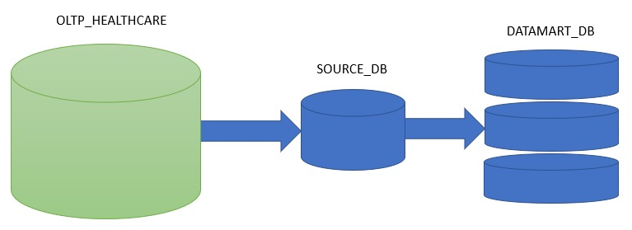

**Resources:**

<https://catalog.data.gov/organization/hhs-gov>

<https://www.healthdata.gov/search/type/dataset>

<https://bchi.bigcitieshealth.org/indicators/1892/11651>

<https://hcup-us.ahrq.gov/databases.jsp>

<https://archive.ics.uci.edu/ml/datasets/MHEALTH+Dataset>